**EXPENSE TRACKER**

**1.Introduction**

**1.1] Need of project/Problem Definition**

Effective financial management is essential for individuals, enabling them to reach their financial objectives and ensure a secure financial future. Often, both small and large business owners, overwhelmed by their hectic schedules, postpone tracking their expenses. Similarly, uneducated or rural individuals engaged in small-scale businesses may lack the expertise to monitor their expenditures, potentially hindering their ability to fully enjoy their profits.

Our project, Expense Tracker, will help individuals to monitor and track the income and expenditures based on their categories. It is a web-based application that will serve as a platform for consumers by facilitating real-time data analysis of income and expenses at a single stop. Our project distinguishes itself from current expense tracker technologies by providing multilingual support, rendering it a valuable tool for local business people, entrepreneurs, and industrialists.

**1.2] Project Objectives**

- To provide users with a secure and user-friendly expense tracking platform.

- To offer real-time data analysis, customizable categories and AI-based recommendations for efficient financial management.

**2.Litrature Survey**

1] "eExpense: A Smart Approach to Track Everyday Expense",S. A. Sabab, S. S. Islam, M. J. Rana and M. Hossain(2018): eExpense is an Android application that simplifies expense tracking. Users can scan bills or receipts, and the app extracts text information, saving amounts and descriptions for processing. It also monitors income by tracking SMS notifications from savings accounts. The application calculates income and expenses to provide users with monthly and yearly balance reports, offering a smart and automated solution for efficient expense management, eliminating the need for manual calculations and data entry.

**Reference** : S. A. Sabab, S. S. Islam, M. J. Rana and M. Hossain, 2018 4th International Conference on Electrical Engineering and Information & Communication Technology (iCEEiCT), Dhaka, Bangladesh, 2018, pp. 136-141, doi: 10.1109/CEEICT.2018.8628070.

2] "Development of an Application for Expense Accounting", D. E. Yurochkin, A. A. Horoshiy and S. A. Karpukhin(2021): This article outlines the development of a mobile application for efficient expense tracking and budget management. The app functions by scanning receipts with a phone camera, preprocessing the image, and performing text recognition to extract and store essential data in a database. The study primarily focused on implementing a robust text recognition algorithm, identifying the necessary data fields, and successfully resolving these complex tasks. Additionally, it addressed the challenges of preserving and managing this data. While the development process is ongoing, the ultimate goal is to create a user-friendly mobile application for expense tracking and the ability to split purchases.

**Reference**: D. E. Yurochkin, A. A. Horoshiy and S. A. Karpukhin, 2021 IEEE Conference of Russian Young Researchers in Electrical and Electronic Engineering (ElConRus), St. Petersburg, Moscow, Russia, 2021, pp. 753-757, doi: 10.1109/ElConRus51938.2021.9396201.

3] "Plenary talk: Enterprise telecom expense management", M. K. Saravanan (2011): Fortune 500 companies allocate 3.6% of their top-line revenues to telecommunications expenses, with visibility and asset management ranking as their top challenges in Telecom Expense Management (TEM). Failing to adopt proactive cost management approaches leveraging technology can result in a 12% to 18% loss. Effective bill, inventory, and contract management are critical components to control expenses. This talk explores identifying spending leakages, managing contracts, and offers insights into Eastcom's cost optimization solutions, including TELCAAP, CCAAP, and Costimiser, with a concluding case study.

**Reference**: M. K. Saravanan ,2011 International Conference on Recent Trends in Information Technology (ICRTIT), Chennai, India, 2011, pp. 12-12, doi: 10.1109/ICRTIT.2011.5972494.

**3.Comparison with existing implementations**

|  |  |  |
| --- | --- | --- |
| 1.Expensify | Expensify is a helpful tool for both people and organisations to manage their costs and produce reports for tax and reimbursement purposes. | 1)User Interface Complexity: Some users find the user interface to be complex and overwhelming  2)Price: Expensify can be relatively expensive, particularly for small businesses or individuals with limited budgets. |
| 2.Cashew | Cashew is a helpful tool for managing personal finances while on the go and keeping track of expenditures. | 1)Technical Glitches: There are various issues like app crashes, slow performance, or error messages when using the app.  2)Compatibility Issues: Problems with the app not working well on certain devices, operating systems |
| 3.Pocket guard | Offer a variety of functions for managing personal money, such as budgeting, goal-setting, and investment tracking. | 1)User Interface and Usability: Complaints about the app's design, layout, or usability, making it hard for users to navigate and perform tasks.  2)Login or Authentication Problems: Users encounter difficulties in logging in, resetting passwords, or verifying their identity. |

**4.Implementation/Methodology**

**4.1] Key Features**

1. Email based Secure Login: The expense tracker ensures secure access with an Email based login system, adding an extra layer of protection to your financial data.

2. Customizable Categories: Users can create and customizeexpense categories to align with their unique spending habits and financial goals.

3. Real-Time Data Analytics: Get immediate insights into your spending patterns with real-time data analytics. Interactive pie charts and curved line graphsprovide a visual representation of your financial data.

4. AI-Based Recommendation System: The AI engine studies your expense reports and offers personalized recommendations to optimize your spending, save more, and achieve your financial goals faster.

6. Multiple Lingual Support: We provide multiple languages support, ensuring a global user base can benefit from its features.

**4.2] Technology Stack**

The expense tracker is built using a robust and secure technology stack that includes the latest web development technologies and AI frameworks for data analysis and recommendations.

**4.3] Monetization and Sustainability**

We can adopt a freemium model, offering basic features for free and premium features with a subscription. This approach ensures sustainability while providing value to users.

**4.4] Prototype**

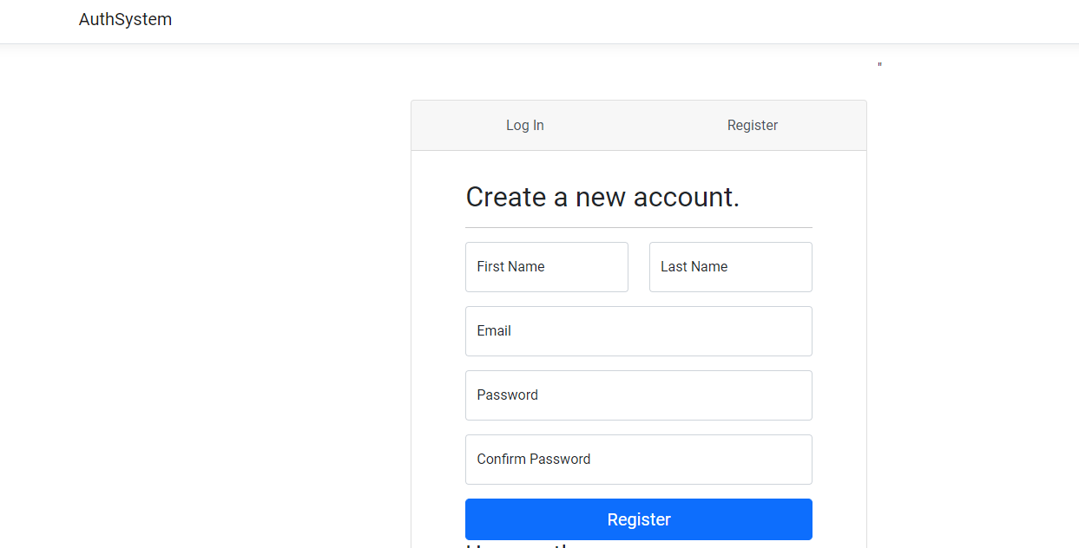

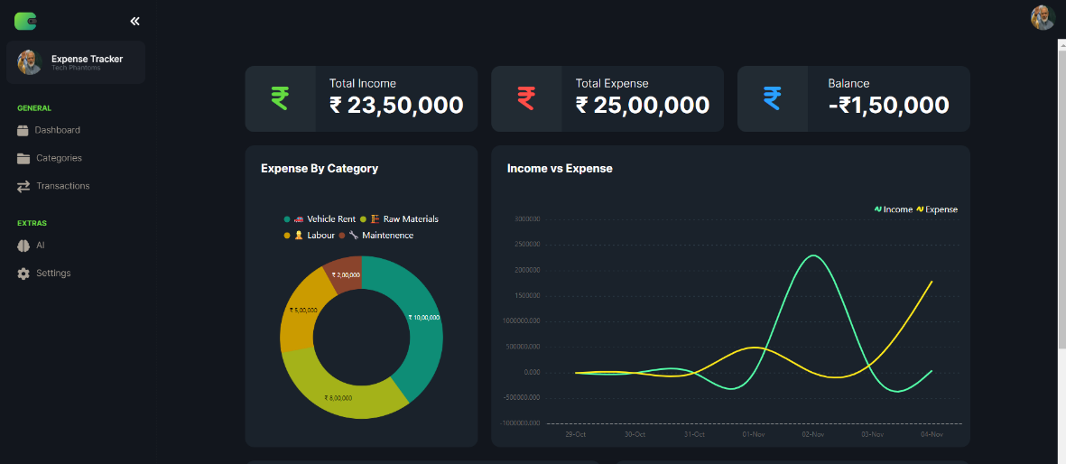

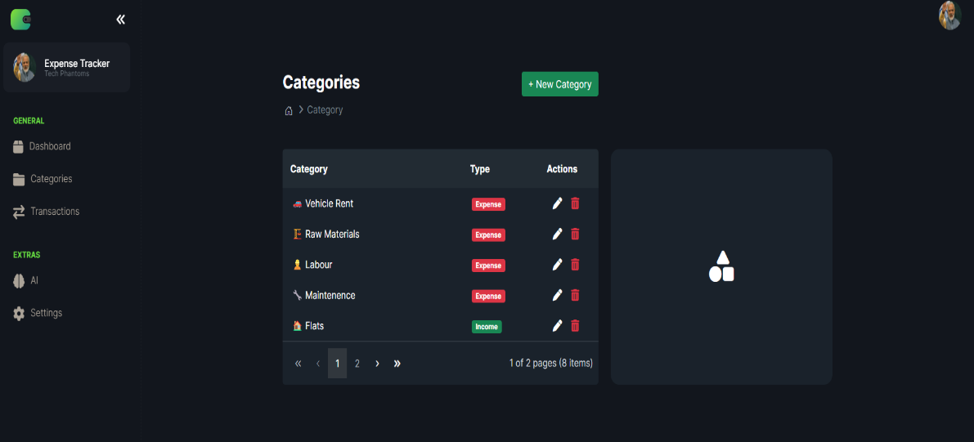

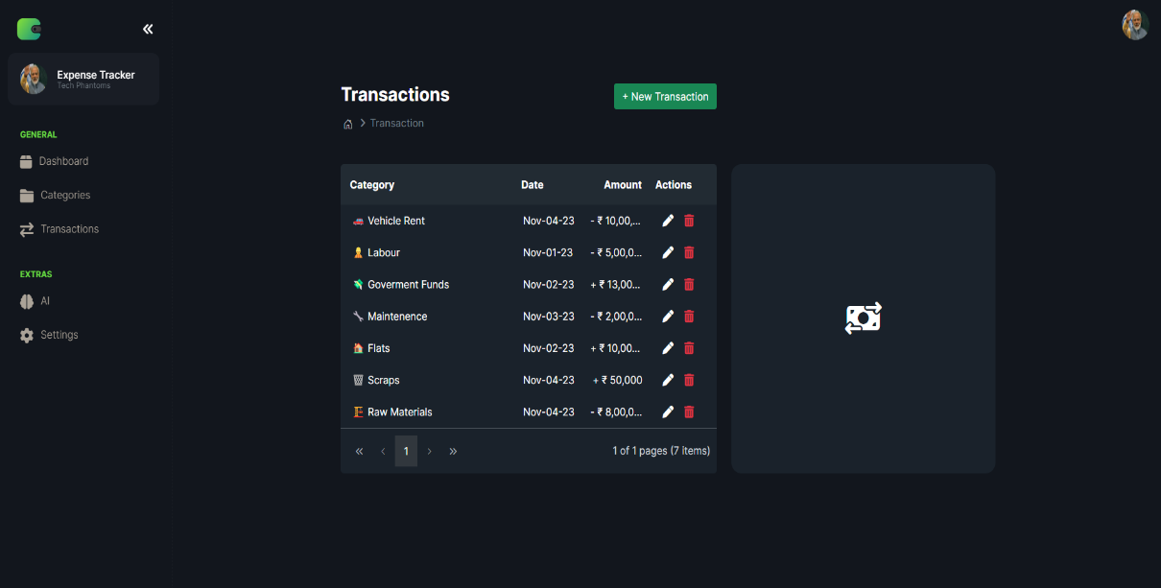

**5.Conclusion/Future Scope**

Our Expense Tracker aims to empower users with a secure, customizable, and intelligent expense tracking solution. With features like Email-based login, customizable categories, real-time analytics, multi- lingual support it is designed to transform the way individuals manage their finances.

**References**

1.Syncfusion

2.OpenAI